

Unity University

**College of Engineering, Technology and Computational Science**

**Department of Computer Science and MIS**

**Integrated AI Surveillance & Satellite Data Analysis System for Causality Reporting**

**By: Arsema Haileyesus UU 90423R Lukman Ali UU 89403R Michael Seyoum UU 91431R Nahom Teguade UU 90479R Nebyu Yohannes UU 90466R**

**April 27, 2024**

Submmited TO: Mr Yishak

# Chapter One - Introduction

## 1.1 Background (Project Overview)

Our project focuses on developing an Integrated AI Surveillance & Satellite Data Analysis System for Causality Reporting. This system aims to address the challenges faced by organizations involved in monitoring and analyzing surveillance data for identifying incidents and generating reports accurately and efficiently. In many sectors such as law enforcement, emergency response, and disaster management, there is a growing need for advanced technologies to streamline data analysis processes and improve decision-making.

Currently, organizations in these sectors rely on manual methods for surveillance data analysis, which are time-consuming, error-prone, and often lack real-time capabilities. Furthermore, the increasing volume and complexity of surveillance data make it challenging for analysts to identify and respond to incidents promptly. Our system aims to overcome these challenges by leveraging artificial intelligence (AI) and satellite data analysis technologies to automate data processing, detect incidents, and generate comprehensive reports.

Main problems to be addressed:

* Manual surveillance data analysis processes are time-consuming and error-prone.
* Difficulty in identifying and responding to incidents promptly due to the increasing volume and complexity of surveillance data.
* Lack of real-time capabilities in existing surveillance systems.

## 1.2 Target Audience Analysis

The target audience for our system includes various stakeholders involved in surveillance, emergency response, and disaster management sectors. These stakeholders can be categorized based on different demographics such as:

* Age: Professionals ranging from young analysts to experienced operators.
* Gender: No specific gender bias; system caters to all genders.
* Education: Analysts with diverse educational backgrounds, ranging from undergraduate to postgraduate degrees in fields such as data science, computer science, and criminology.
* Technical or Non-Technical Users: Both technical users (e.g., data analysts, IT professionals) and non-technical users (e.g., law enforcement officers, emergency responders) will interact with the system.
* Living Standard: Professionals working in various organizations, including government agencies, law enforcement departments, and private security firms.

## 1.3 Objectives

### 1.3.1 General Objective

The general objective of our system is to develop an Integrated AI Surveillance & Satellite Data Analysis System for Causality Reporting that automates data processing, enhances incident detection capabilities, and facilitates the generation of comprehensive reports in real-time.

### 1.3.2 Specific Objectives

* Automate surveillance data processing to improve efficiency and accuracy.
* Enhance incident detection capabilities using artificial intelligence and satellite data analysis.
* Provide real-time monitoring and reporting functionalities to enable prompt response to incidents.
* Facilitate collaboration and information sharing among stakeholders involved in surveillance and emergency response activities.

## 1.4 Scope of the Project

The scope of the Integrated AI Surveillance & Satellite Data Analysis System for Causality Reporting encompasses a range of functionalities aimed at automating surveillance data processing, incident detection, and reporting. These functionalities are designed to enhance situational awareness, improve decision-making, and facilitate efficient emergency response operations. Additionally, the system includes mechanisms for user authentication, access control, and integration with existing surveillance infrastructure. However, certain activities and responsibilities fall outside the project's scope.

### 1.4.1 I n-Scope Functionalities:

1. **Automated Surveillance Data Processing:**
   * Collection, preprocessing, and normalization of raw surveillance data from diverse sources, including cameras, sensors, and satellite imagery.
   * Cleaning, filtering, and transformation of raw data into structured formats suitable for analysis.
2. **Incident Detection and Classification:**
   * Utilization of AI algorithms and satellite data analysis techniques for real-time incident detection and classification.
   * Integration of machine learning models to identify patterns, anomalies, and potential threats within surveillance data.
3. **Real-Time Monitoring and Reporting:**
   * Continuous monitoring of surveillance data streams to identify critical events and trigger alert notifications.
   * Generation of comprehensive incident reports containing detailed information about detected incidents, including timestamps, locations, and severity levels.
4. **Integration with Existing Systems:**
   * Seamless integration with existing surveillance systems, emergency response platforms, and external data sources.
   * Establishment of APIs and web services for data exchange and interoperability with third-party applications.
5. **User Authentication and Access Control:**
   * Implementation of robust authentication mechanisms, such as multi-factor authentication (MFA) and role-based access control (RBAC), to verify user identities and enforce access permissions.
   * Provision of secure user interfaces for accessing system functionalities based on user roles and permissions.

### 1.4.2 Out-of-Scope Activities:

1. **Physical Deployment and Installation:**
   * Deployment and installation of surveillance hardware components, including cameras, sensors, and communication devices, are outside the scope of the project and are typically handled by specialized installation teams.
2. **Legal and Regulatory Compliance:**
   * Compliance with legal and regulatory requirements related to data privacy, surveillance activities, and emergency response operations falls outside the project's purview. However, the system design may include features to facilitate compliance efforts, such as data encryption and audit logging.
3. **End-User Training:**
   * Training and capacity building for end-users on the operation and usage of the system are not included in the project scope. Training activities may be conducted separately by organizations or training providers to ensure effective utilization of the system.

## 1.5 Tools and Methodologies

### 1.5.1 Methodology

For the development of the Integrated AI Surveillance & Satellite Data Analysis System for Causality Reporting, we will adopt Object-Oriented Systems Analysis and Design (OOSAD) methodology. OOSAD is a systematic approach that emphasizes the modeling of real-world entities as objects with properties and behaviors. This methodology is well-suited for complex systems like ours due to its focus on abstraction, modularity, and reusability.

#### Advantages of Using OOSAD:

1. **Modularity and Reusability:**
   * OOSAD promotes modular design, where system components are encapsulated within objects with well-defined interfaces. This modular structure facilitates code reuse, simplifies maintenance, and allows for the easy addition or modification of features.
2. **Abstraction and Encapsulation:**
   * By abstracting real-world entities into objects and encapsulating their properties and behaviors, OOSAD enables a clear separation of concerns. This abstraction layer helps in managing system complexity, promoting code readability, and supporting future enhancements.
3. **Iterative Development:**
   * OOSAD supports an iterative and incremental development approach, allowing for the progressive refinement of system requirements, design, and implementation. Iterative cycles of analysis, design, implementation, and testing enable continuous feedback and validation, leading to the delivery of high-quality software.
4. **Adaptability to Changing Requirements:**
   * In our dynamic and evolving domain of surveillance and emergency response, OOSAD provides the flexibility to accommodate changing requirements and emerging technologies. The iterative nature of OOSAD allows stakeholders to refine and prioritize requirements based on evolving needs and user feedback.
5. **Model-Driven Development:**
   * OOSAD emphasizes the creation of detailed models to represent system structure, behavior, and interactions. These models, including class diagrams, sequence diagrams, and state diagrams, serve as blueprints for system development, fostering better communication among stakeholders and guiding implementation efforts.
6. **Support for Object-Oriented Principles:**
   * OOSAD aligns with fundamental principles of object-oriented programming, such as encapsulation, inheritance, and polymorphism. Leveraging these principles enables the creation of well-structured, maintainable, and extensible software solutions.

By leveraging the advantages of OOSAD, we aim to develop a robust, scalable, and maintainable system that meets the evolving needs of our stakeholders in the surveillance and emergency response domain.

### 1.5.2 Document Preparation Tools

For documentation preparation, we will primarily use Microsoft Office Suite, including Word for writing documents, Excel for data analysis and management, and PowerPoint for creating presentations. These tools are chosen for their widespread compatibility and familiarity among team members.

### 1.5.3 System Design Tools

In our project, system design will be facilitated using modern and versatile tools such as PlantUML, Figma, and FigJam. While traditional tools like Lucidchart and Microsoft Visio are commonly used for system design, we have opted for these alternatives due to their unique advantages and compatibility with our development process.

#### Tools Utilized:

1. **PlantUML:**
   * PlantUML is a text-based diagramming tool that allows us to create various types of diagrams, including Unified Modeling Language (UML) diagrams, sequence diagrams, and activity diagrams, using a simple and expressive syntax. By leveraging PlantUML, we can efficiently generate diagrams directly from textual descriptions, enabling collaboration, version control, and integration with our documentation workflow.
2. **Figma:**
   * Figma is a collaborative interface design tool that offers powerful features for creating user interface (UI) designs, wireframes, and prototypes. With its cloud-based platform and real-time collaboration capabilities, Figma enables our team to collaborate seamlessly on UI design tasks, iterate rapidly, and gather feedback from stakeholders in a centralized environment. By using Figma, we ensure that our system's user interface is visually appealing, intuitive, and responsive to user needs.
3. **FigJam:**
   * FigJam is an online whiteboarding tool that facilitates brainstorming, ideation, and collaborative diagramming sessions. With its diverse set of pre-built shapes, templates, and sticky notes, FigJam allows our team to visualize system concepts, workflows, and architecture in a flexible and interactive manner. By utilizing FigJam, we promote team collaboration, foster creativity, and capture valuable insights during the early stages of system design.

#### Advantages of Using These Tools:

1. **Efficiency and Productivity:**
   * PlantUML's text-based approach streamlines the creation of diagrams, reducing the time and effort required for diagramming tasks. Figma's cloud-based platform enables real-time collaboration and seamless sharing of design assets, fostering productivity and efficiency among team members. FigJam's interactive whiteboarding features promote collaborative brainstorming sessions and accelerate the generation of system design ideas.
2. **Flexibility and Adaptability:**
   * PlantUML's support for version control systems and integration with documentation tools enhances flexibility and adaptability in our development process. Figma's responsive design capabilities enable us to create UI designs that adapt to various screen sizes and devices, ensuring a consistent user experience across platforms. FigJam's flexible canvas and rich set of collaboration tools empower our team to explore different design alternatives and iterate rapidly based on feedback.
3. **Visualization and Communication:**
   * By using these tools, we can visually represent system architecture, design decisions, and user interactions in a clear and comprehensible manner. This promotes better communication among team members, stakeholders, and clients, aligning everyone towards a common vision for the system.

In summary, the adoption of PlantUML, Figma, and FigJam enables us to streamline system design, foster collaboration, and create visually compelling representations of our system's architecture and user interface, ultimately enhancing the quality and effectiveness of our development process.

### 1.5.4 System Development Tools

In our system development process, we will leverage a combination of specialized tools and platforms to facilitate efficient coding, collaboration, and deployment. While traditional integrated development environments (IDEs) such as PyCharm, and Eclipse are commonly used, we have opted for a more tailored approach using MakerSuite, Visual Studio Code (VSCode), and the OpenAI platform.

#### Tools Utilized:

1. **MakerSuite:**
   * MakerSuite is a comprehensive platform that offers a suite of tools and resources specifically designed for AI development and deployment. It provides integrated solutions for data preprocessing, model training, testing, and deployment, streamlining the end-to-end AI development lifecycle. By utilizing MakerSuite, we can accelerate the development process, optimize AI algorithms, and deploy models seamlessly across various environments.
2. **Visual Studio Code (VSCode):**
   * Visual Studio Code is a lightweight and versatile code editor that offers robust features for code editing, debugging, and version control. With its extensive library of extensions and integrations, VSCode supports a wide range of programming languages, frameworks, and tools, making it ideal for diverse development tasks. By using VSCode, we ensure a consistent and efficient coding experience for developers, enabling them to write high-quality code and collaborate effectively on project tasks.
3. **OpenAI Platform:**
   * The OpenAI platform provides access to state-of-the-art artificial intelligence models, APIs, and tools for natural language processing (NLP), image recognition, and other AI tasks. Leveraging OpenAI's pre-trained models and APIs, we can enhance the functionality of our system with advanced AI capabilities, such as sentiment analysis, object detection, and content generation. By integrating OpenAI into our system, we empower users with powerful AI-driven features and insights, enriching their overall experience and productivity.

#### Advantages of Using These Tools:

1. **Streamlined Development Workflow:**
   * MakerSuite's end-to-end AI development capabilities enable us to streamline the development workflow, from data preprocessing to model deployment. This accelerates the development cycle, reduces overhead, and improves overall productivity.
2. **Versatile and Extensible Code Editing:**
   * Visual Studio Code's rich ecosystem of extensions and integrations provides developers with a versatile and extensible code editing environment. This enhances code quality, promotes consistency, and supports seamless integration with other development tools and services.
3. **Access to Cutting-edge AI Technologies:**
   * By leveraging the OpenAI platform, we gain access to cutting-edge AI technologies and models, empowering our system with advanced capabilities for natural language understanding, image processing, and decision-making. This enables us to deliver innovative and intelligent solutions that meet the evolving needs of our users.

The adoption of MakerSuite, Visual Studio Code, and the OpenAI platform enables us to develop a robust, scalable, and intelligent system that delivers superior performance, functionality, and user experience. These tools empower our development team to innovate rapidly, collaborate effectively, and deliver value-added solutions to our users.

**1.5.5 System Development Languages**

In our system development process, we will employ a combination of programming languages tailored to the specific needs and requirements of different components. Our primary languages include:

1. **Next.js for Frontend Development:**
   * Next.js is a versatile and powerful framework for building modern web applications with React. It offers features such as server-side rendering, static site generation, and automatic code splitting, enabling us to create fast, efficient, and SEO-friendly web interfaces. By leveraging Next.js, we can develop interactive and responsive user interfaces that provide seamless navigation and a rich user experience.
2. **Node.js for Backend Development:**
   * Node.js is a lightweight and scalable runtime environment for executing JavaScript code on the server side. It offers non-blocking I/O operations and event-driven architecture, making it well-suited for building high-performance and real-time web applications. With Node.js, we can develop robust backend services and APIs that handle data processing, authentication, and business logic efficiently.
3. **MongoDB for Database Management:**
   * MongoDB is a flexible and scalable NoSQL database that stores data in a JSON-like format, known as BSON. It offers features such as document-based storage, dynamic schema, and horizontal scalability, making it ideal for handling large volumes of unstructured data. By using MongoDB, we can store and retrieve data quickly, perform complex queries, and scale our database infrastructure as needed to support growing data demands.
4. **Python for AI Development:**
   * Python is a versatile and widely-used programming language known for its simplicity, readability, and extensive libraries for AI and data analysis tasks. We will utilize Python for developing AI algorithms, machine learning models, and data processing pipelines, leveraging libraries such as TensorFlow, PyTorch, and scikit-learn. Additionally, we may utilize FastAPI, a Python web framework, to develop RESTful APIs for serving AI models and integrating them into our system.

By leveraging these development languages and frameworks, we ensure a comprehensive and cohesive approach to building our system, encompassing both frontend and backend components, data management, and AI-driven functionalities. This enables us to deliver a robust, scalable, and intelligent solution that meets the evolving needs of our users and stakeholders.

## 1.6 System Architecture

### 1.6.1 Overview of System Architecture

The system architecture of the Integrated AI Surveillance & Satellite Data Analysis System for Causality Reporting is designed to provide a scalable, reliable, and efficient platform for automating surveillance data processing, incident detection, and report generation. The architecture encompasses various components, including data ingestion, processing, analysis, storage, and presentation layers, each fulfilling specific functionalities to achieve the system's objectives.

### 1.6.2 High-Level System Components

The high-level components of the system architecture include:

* Data Ingestion Layer: Responsible for collecting raw surveillance data from multiple sources, such as cameras, sensors, and satellite imagery. This layer preprocesses and normalizes the incoming data before forwarding it to the processing layer.
* Processing Layer: Executes data processing tasks, including cleaning, filtering, and transforming raw data into structured formats suitable for analysis. This layer also integrates artificial intelligence (AI) algorithms and satellite data analysis techniques to detect and classify incidents in real-time.
* Storage Layer: Stores processed data, incident reports, and other relevant information in a centralized database or data warehouse. The storage layer ensures data integrity, durability, and accessibility for subsequent retrieval and analysis.
* Presentation Layer: Provides user interfaces (UIs) for interacting with the system, including web-based dashboards, reporting tools, and mobile applications. These interfaces enable users to monitor surveillance data, view incident reports, and perform administrative tasks such as user management and system configuration.

### 1.6.3 System Integration and Interoperability

The system architecture emphasizes seamless integration and interoperability with existing surveillance systems, emergency response platforms, and external data sources. Integration points include:

* APIs and Web Services: Expose interfaces for data exchange and communication with external systems, allowing seamless integration and interoperability.
* Data Formats and Standards: Adhere to industry-standard data formats and protocols to facilitate interoperability with third-party systems and ensure compatibility with existing infrastructure.
* Middleware and Integration Tools: Utilize middleware solutions and integration tools to streamline data exchange and interoperability between heterogeneous systems, reducing complexity and enhancing scalability.

### 1.6.4 Scalability and Performance Considerations

The system architecture is designed to be scalable and capable of handling large volumes of surveillance data with high performance and reliability. Key considerations include:

* Distributed Processing: Employ distributed computing techniques to parallelize data processing tasks across multiple nodes or clusters, enabling horizontal scalability and improved throughput.
* Load Balancing: Implement load balancing mechanisms to evenly distribute workload among system components, optimizing resource utilization and minimizing response times.
* Caching and Replication: Utilize caching and replication strategies to reduce latency and improve data access speeds, especially for frequently accessed or critical data.
* Monitoring and Optimization: Incorporate monitoring and optimization tools to track system performance metrics, identify bottlenecks, and fine-tune system parameters for optimal efficiency and resource utilization.

### 1.6.5 Security and Privacy Measures

The system architecture incorporates robust security and privacy measures to safeguard sensitive surveillance data and ensure compliance with regulatory requirements. Security features include:

* Authentication and Authorization: Implement user authentication mechanisms such as multi-factor authentication (MFA) and role-based access control (RBAC) to verify user identities and enforce access permissions.
* Encryption and Data Masking: Apply encryption techniques to protect data both at rest and in transit, ensuring confidentiality and integrity. Additionally, use data masking methods to anonymize sensitive information and prevent unauthorized access.
* Audit Logging and Monitoring: Enable comprehensive audit logging and monitoring capabilities to track user activities, detect suspicious behavior, and facilitate forensic analysis in case of security incidents.
* Compliance and Governance: Adhere to relevant security standards and regulations, such as GDPR, HIPAA, and PCI DSS, to ensure compliance with legal and regulatory requirements related to data privacy and security.

The system architecture of the Integrated AI Surveillance & Satellite Data Analysis System for Causality Reporting provides a robust foundation for automating surveillance data processing, incident detection, and report generation. By leveraging advanced technologies and best practices in system design and implementation, the architecture ensures scalability, performance, security, and interoperability, enabling organizations to enhance situational awareness, improve decision-making, and mitigate risks effectively.

# Chapter Two - Requirement Analysis Determination

## 2.1 Overview

In this chapter, we will delve into the detailed analysis of requirements for our system. This includes identifying functional and nonfunctional requirements, constraints, and system models to ensure a comprehensive understanding of the project scope and objectives.

## 2.2 Functional Requirements

### Functional Requirements

#### 1. User Management:

* **Register (Add) Users:**
  + The system should allow an administrator to register new users, including analysts, operators, and first responders.
* **Login:**
  + Users should be able to log in using their credentials.
* **Logout:**
  + Users should be able to log out of the system to end their session securely.

#### 2. Analyst:

* **Generate Reports:**
  + Analysts should be able to generate reports based on surveillance findings, spatial analysis results, and causality insights.
* **Analyze Footage:**
  + Analysts should be able to analyze surveillance footage for objects, anomalies, or suspicious behavior using AI algorithms.
* **Conduct Data Mining:**
  + Analysts should be able to conduct data mining on integrated surveillance and satellite data.
* **Extract Image from Satellite Image Module:**
  + Analysts should be able to extract images from the satellite image processing module for analysis.
* **Identify Correlations and Trends to Feed the AI:**
  + Analysts should be able to identify correlations and trends in the data to feed the AI.

#### 3. Operator:

* **Access and Review Reports:**
  + Operators should be able to access and review reports generated by the system, which include surveillance findings, spatial analysis results, and causality insights.
* **Set Casualty Rate:**
  + Operators should be able to set casualty rates for specific incidents.
* **Assign First Responders:**
  + Operators should be able to assign first responders to specific incidents.

#### 4. First Responder:

* **Access Report:**
  + First responders should be able to access and review reports generated by the system.
* **Save Report:**
  + First responders should be able to save reports for future reference.
* **Raise Issue to Operator:**
  + First responders should be able to raise issues to the operator for further action.
* **Upload Ground Footage:**
  + First responders should be able to upload ground footage related to specific incidents.

#### 5. Data Mining Engine:

* **Send Searched Data:**
  + The data mining engine should send searched data to the analyst.

#### 6. Satellite Image Processing Module:

* **Send Compressed Footage (Image):**
  + The satellite image processing module should send compressed footage (image) to the analyst.

### 2.2.2 Functional Requirements Explanation:

The system's functional requirements outline the core functionalities that it must provide to fulfill the needs of users and stakeholders. These functionalities encompass user management, data analysis, report generation, and integration with external modules.

* **User Management:** Users, including administrators, analysts, operators, and first responders, should be able to register, login, and logout of the system securely.
* **Analyst Functions:** Analysts play a crucial role in generating reports, analyzing surveillance footage, conducting data mining, and identifying correlations and trends to feed the AI algorithms.
* **Operator Functions:** Operators are responsible for accessing and reviewing reports, setting casualty rates, and assigning first responders to specific incidents.
* **First Responder Functions:** First responders have the capability to access and review reports, save reports for future reference, raise issues to operators, and upload ground footage related to specific incidents.
* **Data Mining Engine and Satellite Image Processing Module:** These modules provide essential functionalities such as sending searched data to analysts and sending compressed footage (image) to analysts for further analysis.

By implementing these functional requirements, the system will be able to automate surveillance data processing, facilitate incident detection and classification, enable real-time monitoring, and ensure seamless integration with existing surveillance systems and emergency response platforms.

## 2.3 Nonfunctional Requirements

#### 1. Performance:

* **Real-time Processing:**
  + The system should process and analyze real-time surveillance footage with minimal delay to ensure timely incident detection and response.
* **Data Mining Efficiency:**
  + Data mining operations should be completed within a reasonable time frame, even with large datasets, to provide timely insights to analysts.

#### 2. Scalability:

* **User and Incident Handling:**
  + The system should be designed to handle a large number of users and incidents without compromising performance, ensuring scalability as the user base and data volume grow.

#### 3. Usability:

* **Intuitive User Interface:**
  + The user interface should be intuitive and user-friendly, allowing users to navigate the system with minimal training and effort.
* **Clear and Informative Reports:**
  + The system should provide clear and informative reports that are easy to understand, aiding users in making informed decisions based on the analysis results.

#### 4. Security:

* **Secure Authentication and Authorization:**
  + The system should ensure secure authentication and authorization mechanisms to protect sensitive data and prevent unauthorized access.
* **Password Security:**
  + User passwords should be stored securely using encryption to safeguard user accounts from potential breaches.
* **Role-based Access Control:**
  + Access to the system should be role-based, with different levels of access for analysts, operators, and first responders, ensuring that each user has access only to the necessary functionalities.

#### 5. Reliability:

* **High Availability:**
  + The system should be available 24/7 with minimal downtime for maintenance, ensuring continuous operation to support critical surveillance and response activities.
* **Fault Recovery:**
  + The system should be capable of recovering from failures quickly and without data loss to minimize disruptions in service.

#### 6. Integration:

* **Seamless Integration:**
  + The system should integrate seamlessly with existing surveillance systems and satellite image processing modules, enabling interoperability and data sharing between different platforms.
* **Support for Various Data Formats:**
  + The system should support various data formats for integration, ensuring compatibility with diverse data sources and systems.

#### 7. Accuracy:

* **Accurate Analysis:**
  + The system should provide accurate analysis and causality insights to support decision-making effectively, minimizing errors and false alarms.

#### 8. Maintainability:

* **Ease of Maintenance:**
  + The system should be easy to maintain and update to accommodate changes in requirements or technology, reducing the effort and cost associated with system maintenance over time.

#### 9. Compliance:

* **Regulatory Compliance:**
  + The system should comply with relevant data protection regulations and standards to ensure the privacy and security of user data and adherence to legal requirements.

**2.3.1 System Interfacing**

#### Seamless Integration:

* + The system's architecture facilitates seamless integration with external systems and APIs, ensuring interoperability and data exchange between various system components. For example, the surveillance data processing module interfaces with external data sources, such as surveillance cameras and sensors, to collect real-time data for analysis.

#### API Compatibility:

* + The system's data mining engine exposes APIs that allow external systems to query and retrieve data for analysis. These APIs are compatible with industry standards and protocols, enabling easy integration with third-party applications and services.

**2.3.2 Quality Issues**

#### Adherence to Standards:

* + The development team follows established coding standards and best practices when designing and implementing system components. For instance, the AI algorithms used for incident detection and classification adhere to industry-standard machine learning practices to ensure accuracy and reliability.

#### Quality Assurance:

* + Rigorous quality assurance processes, including unit testing, integration testing, and system testing, are employed to verify the functionality, performance, and security of the system. Automated testing tools are used to identify and address defects in the software.

**2.3.3 System Modifications**

#### Flexibility and Customization:

* + The system is designed with modularity in mind, allowing for easy customization and modification of system components. For example, new AI algorithms can be seamlessly integrated into the system to enhance surveillance data analysis capabilities without disrupting existing functionality.

#### Modular Design:

* + System components are developed as independent modules with well-defined interfaces, enabling developers to modify or replace individual modules without affecting the overall system architecture. This modular design approach facilitates system scalability and maintainability.

**2.3.4 Physical Environment**

#### Environmental Considerations:

* + The system's hardware components are designed to withstand the physical environment in which they operate, including temperature fluctuations, humidity levels, and space constraints. For example, ruggedized surveillance cameras are deployed in outdoor environments to ensure durability and reliability.

**2.3.5 Security Issues**

#### Robust Security Measures:

* + The system incorporates robust security measures to protect sensitive data and prevent unauthorized access. For instance, user authentication mechanisms, such as multi-factor authentication and role-based access control, are implemented to restrict access to confidential information.
* **Data Privacy:**
  + Data privacy regulations, such as GDPR and HIPAA, are strictly adhered to, ensuring that user data is collected, processed, and stored in compliance with applicable laws and regulations. Encryption techniques are employed to safeguard data privacy and confidentiality.

## 2.4 System Models

System models provide abstract representations of the system architecture, components, and interactions. These models aid in visualizing and analyzing system behavior and dependencies. Common system models include:

* Usecase diagrams
* Usecase Documentation
* Activity diagrams
* Sequence diagrams
* CRC Card
* Class diagrams

In the subsequent sections of this chapter, we will explore each of these aspects in detail to ensure a thorough understanding of the requirements and constraints governing the system design and development process.

### 2.4.1 Usecase Diagram

The diagram represents the use cases and interactions within the "Integrated AI Surveillance & Satellite Data Analysis for Causality Reporting System." It illustrates the functionalities available to different actors within the system.

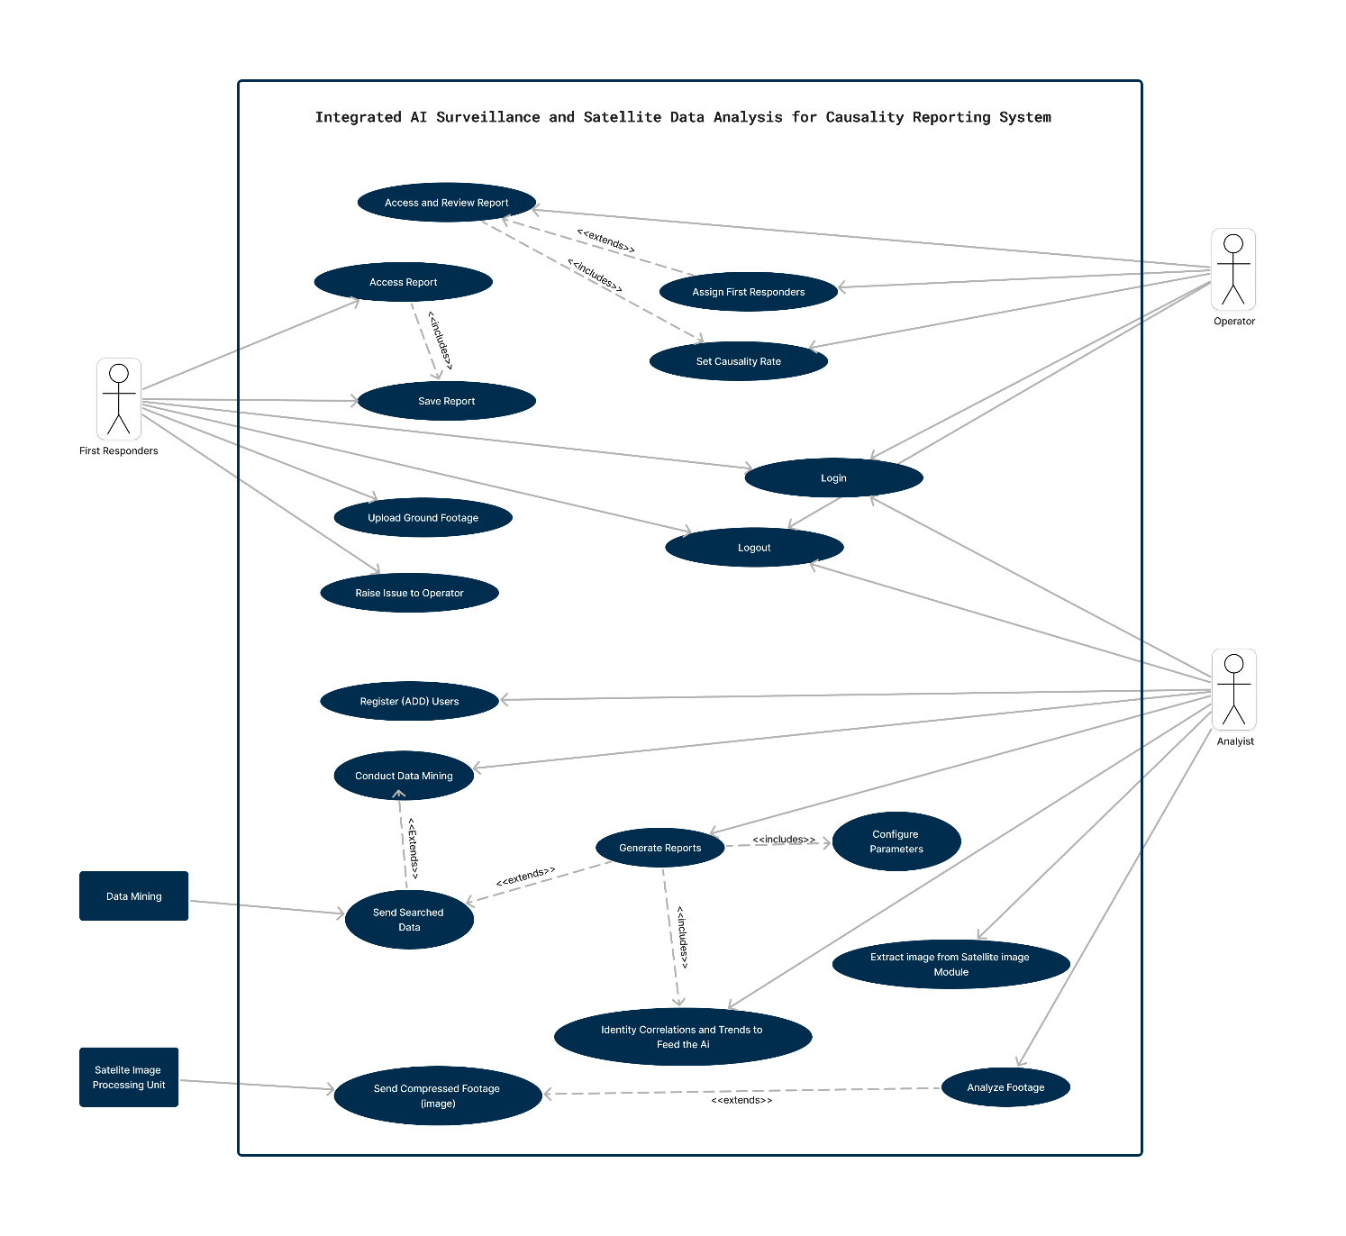

Figure 1 System Usecase Diagram

#### Actors:

* **Analyst:** A user responsible for managing user registrations, generating reports, analyzing surveillance footage, conducting data mining, and identifying correlations and trends.
* **Operator:** A user responsible for accessing and reviewing reports, setting casualty rates, and assigning first responders to incidents.
* **First Responder (Responder):** A user responsible for accessing reports, saving reports, raising issues to operators, and uploading ground footage related to incidents.
* **Data Mining Engine:** An external system boundary responsible for performing data mining operations.
* **Satellite Image Processing Module (ImageModule):** An external system boundary responsible for processing and compressing satellite images.

#### Use Cases:

1. **Register (Add) Users:** Admin can register new users into the system.
2. **Login:** Users can log in to the system.
3. **Logout:** Users can log out of the system.
4. **Generate Reports:** Analysts can generate reports based on surveillance findings and data analysis.
5. **Analyze Footage:** Analysts can analyze surveillance footage using AI algorithms.
6. **Conduct Data Mining:** Analysts can perform data mining on integrated surveillance and satellite data.
7. **Extract Image from Satellite Image Module:** Analysts can extract images from the satellite image processing module for analysis.
8. **Identify Correlations and Trends to Feed the AI:** Analysts can identify correlations and trends in the data to feed the AI.
9. **Access and Review Reports:** Operators can access and review reports generated by the system.
10. **Set Casualty Rate:** Operators can set casualty rates for specific incidents.
11. **Assign First Responders:** Operators can assign first responders to specific incidents.
12. **Access Report:** First responders can access reports generated by the system.
13. **Save Report:** First responders can save reports for future reference.
14. **Raise Issue to Operator:** First responders can raise issues to operators for further action.
15. **Upload Ground Footage:** First responders can upload ground footage related to specific incidents.
16. **Send Searched Data:** The data mining engine can send searched data to analysts.
17. **Send Compressed Footage (Image):** The satellite image processing module can send compressed footage (image) to analysts.
18. **Configure Parameters:** Analysts can configure parameters for report generation, data analysis, and other system functionalities.

#### Relationships:

* The use case "Generate Reports" includes "Identify Correlations and Trends to Feed the AI" and "Configure Parameters."
* The use case "Access and Review Reports" includes "Set Casualty Rate."
* The use case "Raise Issue to Operator" includes "Save Report."
* The use case "Conduct Data Mining" extends "Send Searched Data."
* The use case "Access Report" extends "Save Report."
* The use case "Generate Reports" extends "Send Searched Data."
* The use case "Analyze Footage" extends "Send Compressed Footage (Image)."

### 2.4.2 Usecase Documentation

**Usecase ID: UC_001 - Register (Add) Users**

|  |  |
| --- | --- |
| **Item** | **Description** |
| **Actors** | Administrator |
| **Importance Level** | High |
| **Description** | Enables administrators to register new users into the system. |
| **Pre-condition** | Administrator must be logged into the system. |
| **Post-condition** | New user is successfully registered in the system. |
| **Basic Course of Action** | * 1. Access system.   2. Log in.   3. Navigate to register users.   4. Enter user details.   5. Validate and register user. |
| **Alternative Course of Action** | If username is already in use:   * + 1. Choose a different username.     2. Re-enter user details. |
| **Relationship** | Generalization: None  Association: Analyst  Include: None  Extends: |

**Table 1 Register (Add) Users Usecase Documentation**

* **Actors:** Analyst
* **Importance Level:** High
* **Description:** Administrators add new users to the system.
* **Pre-condition:** Administrator is logged in.
* **Post-condition:** New user is successfully registered.
* **Basic Course of Action:**
  1. Access system.
  2. Log in.
  3. Navigate to user registration.
  4. Enter new user details.
  5. System validates data.
  6. If valid, register new user.
* **Alternative Course of Action:**
  1. If username already exists:
     1. System prompts for unique username.
     2. Admin selects new username.
     3. Repeat steps 5-6.

**Usecase ID: UC_002 - Login**

|  |  |
| --- | --- |
| **Item** | **Description** |
| **Actors** | All Users (Administrator, Analyst, Operator, First Responder) |
| **Importance Level** | High |
| **Description** | Enables users to log into the system using their credentials. |
| **Pre-condition** | User must access the system interface. |
| **Post-condition** | User is successfully logged into the system. |
| **Basic Course of Action** | * 1. Access system.   2. Enter username and password.   3. Validate credentials.   4. Log into system. |
| **Alternative Course of Action** | If credentials are incorrect:  1. Display error message.  2. Re-enter credentials. |
| **Relationship** | Generalization: None  Association: Administrator, Analyst, Operator, First Responder  Include: None  Extends: None |

**Table 2 Log-In Usecase Documentation**

* **Actors:** All Users
* **Importance Level:** High
* **Description:** Users log into the system.
* **Pre-condition:** User accesses system.
* **Post-condition:** User is successfully logged in.
* **Basic Course of Action:**
  1. Access system.
  2. Enter username and password.
  3. System validates credentials.
  4. If correct, user logged in.
* **Alternative Course of Action:**
  1. If credentials incorrect:
     1. System displays error.
     2. User re-enters credentials.
     3. Repeat steps 3-4.

**Usecase ID: UC_003 - Logout**

|  |  |
| --- | --- |
| **Item** | **Description** |
| **Actors** | All Users (Administrator, Analyst, Operator, First Responder) |
| **Importance Level** | Medium |
| **Description** | Enables users to log out of the system, terminating their current session. |
| **Pre-condition** | User must be logged into the system. |
| **Post-condition** | User is successfully logged out of the system. |
| **Basic Course of Action** | * + 1. Select logout option.     2. Terminate session. |
| **Alternative Course of Action** | None. |
| **Relationship** | Generalization: None  Association: Administrator, Analyst, Operator, First Responder  Include: None  Extends: None |

**Table 3 Log-Out Usecase Documentation**

* **Actors:** All Users
* **Importance Level:** Medium
* **Description:** Users log out of the system, terminating their session.
* **Pre-condition:** User is logged in.
* **Post-condition:** User is successfully logged out.
* **Basic Course of Action:**
  1. User selects logout option.
  2. System terminates session and redirects to login page.
* **Alternative Course of Action:**
  1. None.

**Usecase ID: UC_004 - Generating Reports**

|  |  |
| --- | --- |
| **Item** | **Description** |
| **Actors** | Analyst |
| **Importance Level** | High |
| **Description** | Enables analysts to generate reports based on surveillance findings, spatial analysis results, and causality insights. |
| **Pre-condition** | Analyst must be logged into the system. |
| **Post-condition** | Report is successfully generated. |
| **Basic Course of Action** | * + 1. Access system.     2. Log in.     3. Navigate to generate report.     4. Enter report details.     5. Validate and generate report. |
| **Alternative Course of Action** | If entered data is incomplete or invalid:  1. Prompt analyst to correct errors.  2. Correct errors and resubmit. |
| **Relationship** | Generalization: None  Association: Analyst  Include: Identify Correlations and Trends to Feed the AI, Configure Parameters  Extends: None |

**Table 4 Generate Reports Usecase Documentation**

* **Actors:** Analyst
* **Importance Level:** High
* **Description:** Analysts generate reports based on surveillance findings and data analysis.
* **Pre-condition:** Analyst is logged in.
* **Post-condition:** Report is successfully generated.
* **Basic Course of Action:**
  1. Access system.
  2. Log in.
  3. Navigate to report generation.
  4. Enter report details and findings.
  5. System validates data.
  6. If valid, generate report.
* **Alternative Course of Action:**
  1. If data incomplete or invalid:
     1. System prompts for correction.
     2. Analyst corrects data.
     3. Repeat steps 5-6.

**Usecase ID: UC_005 - Analyze Footage**

|  |  |
| --- | --- |
| **Item** | **Description** |
| **Actors** | Analyst |
| **Importance Level** | High |
| **Description** | Enables analysts to analyze footage captured by surveillance systems. |
| **Pre-condition** | Analyst must be logged into the system. |
| **Post-condition** | Footage is successfully analyzed by the analyst. |
| **Basic Course of Action** | * 1. Access system.   2. Log in.   3. Navigate to analyze footage.   4. Select footage for analysis.   5. Process selected footage. |
| **Alternative Course of Action** | If selected footage is corrupt or inaccessible:  1. Display error message.  2. Select alternative footage. |
| **Relationship** | Generalization: None  Association: Analyst  Include: None  Extends: Send Compressed Footage (Image) |

**Table 5 Analyze Footage Usecase Documentation**

* **Actors:** Analyst
* **Importance Level:** High
* **Description:** Analysts analyze footage captured by surveillance systems.
* **Pre-condition:** Analyst is logged in.
* **Post-condition:** Footage is successfully analyzed.
* **Basic Course of Action:**
  1. Access system.
  2. Log in.
  3. Navigate to footage analysis.
  4. Select footage for analysis.
  5. System processes selected footage.
* **Alternative Course of Action:**
  1. If selected footage is corrupt or inaccessible:
     1. System displays error.
     2. Analyst selects alternative footage.
     3. Repeat steps 4-5.

**Usecase ID: UC_006 - Conduct Data Mining**

|  |  |
| --- | --- |
| **Item** | **Description** |
| **Actors** | Analyst |
| **Importance Level** | High |
| **Description** | Enables analysts to conduct data mining operations on the system's database. |
| **Pre-condition** | Analyst must be logged into the system. |
| **Post-condition** | Data mining operation is successfully completed by the analyst. |
| **Basic Course of Action** | * + 1. Access system.     2. Log in.     3. Navigate to conduct data mining.     4. Enter search criteria.     5. Process data. |
| **Alternative Course of Action** | If entered search criteria yield no results:  1. Display message indicating no matching data.  2. Modify search criteria. |
| **Relationship** | Generalization: None  Association: Analyst  Include: None  Extends: Send Compressed Footage (Image) |

**Table 6 Conduct Data Mining Usecase Documentation**

* **Actors:** Analyst
* **Importance Level:** High
* **Description:** Analysts conduct data mining operations on the system's database.
* **Pre-condition:** Analyst is logged in.
* **Post-condition:** Data mining operation is successfully completed.
* **Basic Course of Action:**
  1. Access system.
  2. Log in.
  3. Navigate to data mining.
  4. Enter search criteria.
  5. System retrieves relevant data.
* **Alternative Course of Action:**
  1. If entered search criteria yield no results:
     1. System displays message.
     2. Analyst modifies search criteria.
     3. Repeat steps 4-5.

**Usecase ID: UC_007 - Extract Image from Satellite Image Module**

|  |  |
| --- | --- |
| **Item** | **Description** |
| **Actors** | Analyst |
| **Importance Level** | Medium |
| **Description** | Enables analysts to extract images from the satellite image processing module for further analysis. |
| **Pre-condition** | Analyst must be logged into the system. |
| **Post-condition** | Image is successfully extracted from the satellite image processing module. |
| **Basic Course of Action** | * + 1. Access system.     2. Log in.     3. Navigate to extract images.     4. Select desired image.     5. Retrieve and display image. |
| **Alternative Course of Action** | If selected image is unavailable or corrupt:  1. Display error message.  2. Select alternative image. |
| **Relationship** | Generalization: None  Association:  Analyst Include: None  Extends: None |

**Table 7 Extract Image from Satellite Image Module Usecase Documentation**

* **Actors:** Analyst
* **Importance Level:** Medium
* **Description:** Analysts extract images from the satellite image processing module for further analysis.
* **Pre-condition:** Analyst is logged in.
* **Post-condition:** Image is successfully extracted.
* **Basic Course of Action:**
  1. Access system.
  2. Log in.
  3. Navigate to image extraction feature.
  4. Select image from satellite module.
  5. System retrieves and displays selected image.
* **Alternative Course of Action:**
  1. If selected image is unavailable or corrupt:
     1. System displays error message.
     2. Analyst selects alternative image.
     3. Repeat steps 4-5.

**Usecase ID: UC_008 - Identify Correlations and Trends to Feed the AI**

|  |  |
| --- | --- |
| **Item** | **Description** |
| **Actors** | Analyst |
| **Importance Level** | High |
| **Description** | Enables analysts to identify correlations and trends in surveillance data to improve AI algorithms. |
| **Pre-condition** | Analyst must be logged into the system. |
| **Post-condition** | Correlations and trends are successfully identified and fed into the AI algorithms. |
| **Basic Course of Action** | * 1. Access system.   2. 2. Log in.   3. Navigate to identify correlations and trends.   4. Select data sets.   5. Process data for analysis. |
| **Alternative Course of Action** | If selected data sets are insufficient or irrelevant:  1. Display message indicating unsuitability.  2. Modify search criteria. |
| **Relationship** | Generalization: None  Association: Analyst  Include: None  Extends: None |

**Table 8 Identify Correlations and Trends to Feed the AI Usecase Documentation**

* **Actors:** Analyst
* **Importance Level:** High
* **Description:** Analysts identify correlations and trends in surveillance data to improve AI algorithms.
* **Pre-condition:** Analyst is logged in.
* **Post-condition:** Correlations and trends are successfully identified and fed into the AI.
* **Basic Course of Action:**
  1. Access system.
  2. Log in.
  3. Navigate to correlation identification.
  4. Select relevant data sets.
  5. System processes data to identify correlations and trends.
* **Alternative Course of Action:**
  1. If selected data sets are insufficient or irrelevant:
     1. System displays message.
     2. Analyst selects alternative data sets.
     3. Repeat steps 4-5.

**Usecase ID: UC_009 - Access and Review Reports**

|  |  |
| --- | --- |
| **Item** | **Description** |
| **Actors** | Operator |
| **Importance Level** | High |
| **Description** | Enables operators to access and review generated reports within the system. |
| **Pre-condition** | Operator must be logged into the system. |
| **Post-condition** | Operator successfully accesses and reviews the requested reports. |
| **Basic Course of Action** | 1. Access system.  2. Log in.  3. Navigate to access reports.  4. Select desired report.  5. Retrieve and display report. |
| **Alternative Course of Action** | If selected report is unavailable or inaccessible:  1. Display error message.  2. Select alternative report. |
| **Relationship** | Generalization: None  Association: Operator  Include: Set Casualty Rate  Extends: None |

**Table 9 Access and Review Reports Usecase Documentation**

* **Actors:** Operator
* **Importance Level:** High
* **Description:** Operators access and review generated reports within the system.
* **Pre-condition:** Operator is logged in.
* **Post-condition:** Reports are successfully accessed and reviewed.
* **Basic Course of Action:**
  1. Access system.
  2. Log in.
  3. Navigate to report access.
  4. Select report for review.
  5. System retrieves and displays selected report.
* **Alternative Course of Action:**
  1. If selected report is unavailable or inaccessible:
     1. System displays error.
     2. Operator selects alternative report.
     3. Repeat steps 4-5.

**Usecase ID: UC_010 - Set Casualty Rate**

|  |  |
| --- | --- |
| **Item** | **Description** |
| **Actors** | Operator |
| **Importance Level** | Medium |
| **Description** | Enables operators to set the casualty rate threshold within the system. |
| **Pre-condition** | Operator must be logged into the system. |
| **Post-condition** | Casualty rate threshold is successfully set within the system. |
| **Basic Course of Action** | 1. Access system. 2. Log in. 3. Navigate to set casualty rate. 4. Enter desired threshold. 5. Validate and update threshold. |
| **Alternative Course of Action** | If entered threshold is invalid or out of range:  1. Display error message.  2. Adjust threshold. |
| **Relationship** | Generalization: None  Association: Operator  Include: None  Extends: None |

**Table 10 Set Casualty Rate Usecase Documentation**

* **Actors:** Operator
* **Importance Level:** Medium
* **Description:** Operators set the casualty rate threshold within the system.
* **Pre-condition:** Operator is logged in.
* **Post-condition:** Casualty rate threshold is successfully set.
* **Basic Course of Action:**
  1. Access system.
  2. Log in.
  3. Navigate to casualty rate setting.
  4. Enter desired threshold.
  5. System validates and updates threshold.
* **Alternative Course of Action:**
  1. If entered threshold is invalid or out of range:
     1. System displays error.
     2. Operator adjusts threshold.
     3. Repeat steps 4-5.

**Usecase ID: UC_011 - Assign First Responders**

|  |  |
| --- | --- |
| **Item** | **Description** |
| **Actors** | Operator |
| **Importance Level** | High |
| **Description** | Enables operators to assign first responders to specific incidents or tasks within the system. |
| **Pre-condition** | Operator must be logged into the system. |
| **Post-condition** | First responders are successfully assigned to the specified incidents or tasks. |
| **Basic Course of Action** | 1. Access system. 2. Log in. 3. Navigate to assign first responders. 4. Select incident/task. 5. Assign first responders. |
| **Alternative Course of Action** | If selected incident/task has no available first responders:  1. Display message indicating unavailability.  2. Select alternative incident/task. |
| **Relationship** | Generalization: None  Association: Operator  Include: None  Extends: Access and Review Reports |

**Table 11 Assign First Responders Usecase Documentation**

* **Actors:** Operator
* **Importance Level:** High
* **Description:** Operators assign first responders to specific incidents or tasks within the system.
* **Pre-condition:** Operator is logged in.
* **Post-condition:** First responders are successfully assigned.
* **Basic Course of Action:**
  1. Access system.
  2. Log in.
  3. Navigate to first responder assignment.
  4. Select incident or task.
  5. Assign appropriate first responders.
* **Alternative Course of Action:**
  1. If selected incident or task has no available first responders:
     1. System displays message.
     2. Operator selects alternative incident or task.
     3. Repeat steps 4-5.

**Usecase ID: UC_012 - Access Report**

|  |  |
| --- | --- |
| **Item** | **Description** |
| **Actors** | First Responder |
| **Importance Level** | High |
| **Description** | Enables first responders to access and view reports related to specific incidents or tasks within the system. |
| **Pre-condition** | First responder must be logged into the system. |
| **Post-condition** | First responder successfully accesses and views the requested reports. |
| **Basic Course of Action** | 1. Access system. 2. Log in. 3. Navigate to access reports. 4. Select desired report. 5. Retrieve and display report. |
| **Alternative Course of Action** | If selected report is unavailable or inaccessible:  1. Display error message.  2. Select alternative report. |
| **Relationship** | Generalization: None  Association: First Responder  Include: None  Extends: Save Report |

**Table 12 Access Report Usecase Documentation**

* **Actors:** First Responder
* **Importance Level:** High
* **Description:** First responders’ access and view reports related to specific incidents or tasks within the system.
* **Pre-condition:** First responder is logged in.
* **Post-condition:** Reports are successfully accessed and viewed.
* **Basic Course of Action:**
  1. Access system.
  2. Log in.
  3. Navigate to report access.
  4. Select report for viewing.
  5. System retrieves and displays selected report.
* **Alternative Course of Action:**
  1. If selected report is unavailable or inaccessible:
     1. System displays error.
     2. First responder selects alternative report.
     3. Repeat steps 4-5.

**Usecase ID: UC_013 - Save Report**

|  |  |
| --- | --- |
| **Item** | **Description** |
| **Actors** | First Responder |
| **Importance Level** | Medium |
| **Description** | Enables first responders to save reports related to specific incidents or tasks within the system. |
| **Pre-condition** | First responder must be logged into the system. |
| **Post-condition** | Report is successfully saved by the first responder for future reference. |
| **Basic Course of Action** | 1. Access system. 2. Log in. 3. Navigate to save reports. 4. Select report to save. 5. Save report to designated location. |
| **Alternative Course of Action** | If report cannot be saved due to system error:  1. Display error message.  2. Retry saving report. |
| **Relationship** | Generalization: None  Association: First Responder  Include: None  Extends: None |

**Table 13 Save Report Usecase Documnetation**

* **Actors:** First Responder
* **Importance Level:** Medium
* **Description:** First responders save reports for future reference or sharing within the system.
* **Pre-condition:** First responder is logged in.
* **Post-condition:** Report is successfully saved.
* **Basic Course of Action:**
  1. Access system.
  2. Log in.
  3. Navigate to report.
  4. Select report to save.
  5. Choose "Save" option.
* **Alternative Course of Action:**
  1. None.

**Usecase ID: UC_014 - Raise Issue to Operator**

|  |  |
| --- | --- |
| **Item** | **Description** |
| **Actors** | First Responder |
| **Importance Level** | High |
| **Description** | Enables first responders to raise issues or concerns to the operator for further action within the system. |
| **Pre-condition** | First responder must be logged into the system. |
| **Post-condition** | Issue or concern raised by the first responder is successfully communicated to the operator for resolution. |
| **Basic Course of Action** | 1. Access system. < 2. Log in. 3. Navigate to raise issues. 4. Describe issue or concern. 5. Notify operator. |
| **Alternative Course of Action** | If issue cannot be raised due to system error:  1. Display error message.  2. Contact operator via alternative communication channels. |
| **Relationship** | Generalization: None  Association: First Responder  Include: None  Extends: None |

**Table 14 Raise Issue to Operator Usecase Documentation**

* **Actors:** First Responder
* **Importance Level:** High
* **Description:** First responders raise issues or concerns to operators for further action within the system.
* **Pre-condition:** First responder is logged in.
* **Post-condition:** Issue is successfully raised to operator.
* **Basic Course of Action:**
  1. Access system.
  2. Log in.
  3. Navigate to issue raising.
  4. Describe issue or concern.
  5. Submit issue to operator.
* **Alternative Course of Action:**
  1. None.

**Usecase ID: UC_015 - Upload Ground Footage**

|  |  |
| --- | --- |
| **Item** | **Description** |
| **Actors** | First Responder |
| **Importance Level** | Medium |
| **Description** | First responders upload ground footage or additional evidence related to specific incidents. |
| **Pre-condition** | First responder must be logged in. |
| **Post-condition** | Footage uploaded and associated with the relevant incident. |
| **Basic Course of Action** | 1. Access system. 2. Log in. 3. 3. Navigate to upload button. 4. 4. Select footage to upload. 5. 5. Process and upload footage. |
| **Alternative Course of Action** | If files are corrupted or incompatible:  1. Display error.  2. Select alternative files.  3. Repeat upload process. |
| **Relationship** | Generalization: None  Association: First Responder  Include: None  Extends: None |

**Table 15 Upload Ground Footage Usecase Documentation**

* **Actors:** First Responder
* **Importance Level:** Medium
* **Description:** First responders upload ground footage or additional evidence related to specific incidents within the system.
* **Pre-condition:** First responder is logged in.
* **Post-condition:** Ground footage or additional evidence is successfully uploaded and associated with the relevant incident within the system.
* **Basic Course of Action:**
  1. Access system.
  2. Log in.
  3. Navigate to upload feature.
  4. Select ground footage or evidence files.
  5. Upload selected files.
* **Alternative Course of Action:**
  1. If uploaded files are corrupted or incompatible:
     1. System displays error message.
     2. First responder selects alternative files.
     3. Repeat steps 4-5 until valid files are uploaded.

**Usecase ID: UC_016 - Send Searched Data**

|  |  |
| --- | --- |
| **Item** | **Description** |
| **Actors** | Data Mining Engine |
| **Importance Level** | High |
| **Description** | Engine sends searched data results to requesting user or component. |
| **Pre-condition** | Engine has database access. |
| **Post-condition** | Searched data successfully transmitted. |
| **Basic Course of Action** | 1. Receive search query. 2. Process query against database. 3. Retrieve relevant data. 4. Format and transmit results. |
| **Alternative Course of Action** | If query execution fails:  Generate error.  User refines query or contacts admin. |
| **Relationship** | Generalization: None  Association: Data Mining Engine  Include: None  Extends: None |

**Table 16 Send Searched Data Usecase Documentation**

* **Actors:** Data Mining Engine
* **Importance Level:** High
* **Description:** Data mining engine sends searched data results to the requesting user or system component.
* **Pre-condition:** Data mining engine has access to the relevant database and query processing capabilities.
* **Post-condition:** Searched data results are successfully transmitted to the requesting user or system component.
* **Basic Course of Action:**
  1. Receive search query request.
  2. Process search query against the database.
  3. Retrieve relevant data matching the search query criteria.
  4. Format and transmit the search results to the requesting user or system component.
* **Alternative Course of Action:**
  1. If search query execution fails due to database issues or query errors:
     1. Generate an error message indicating the issue.
     2. Refine the search query or contact the system administrator for assistance.

**Usecase ID: UC_017 - Send Compressed Footage (Image)**

|  |  |
| --- | --- |
| **Item** | **Description** |
| **Actors** | Satellite Image Processing Module |
| **Importance Level** | High |
| **Description** | Module sends compressed footage (image) data to requesting user or system component. |
| **Pre-condition** | Module has access to image data and compression algorithms. |
| **Post-condition** | Compressed footage (image) data successfully transmitted. |
| **Basic Course of Action** | * + 1. Receive request for compressed footage.     2. Retrieve relevant footage data.     3. Apply compression algorithm.     4. Transmit compressed data. |
| **Alternative Course of Action** | If compression process fails:  1. Generate error message.  2. Retry compression. |
| **Relationship** | Generalization: None  Association: Satellite Image Processing Module  Include: None  Extends: None |

**Table 17 Send Compressed Footage (Image) Usecase Documentation**

* **Actors:** Satellite Image Processing Module
* **Importance Level:** High
* **Description:** The satellite image processing module sends compressed footage (image) data to the requesting user or system component.
* **Pre-condition:** The satellite image processing module has access to the relevant image data and compression algorithms.
* **Post-condition:** Compressed footage (image) data is successfully transmitted to the requesting user or system component.
* **Basic Course of Action:**
  1. Receive request for compressed footage (image).
  2. Retrieve relevant footage (image) data.
  3. Apply compression algorithm to the footage (image) data.
  4. Transmit the compressed footage (image) data to the requesting user or system component.
* **Alternative Course of Action:**
  1. If compression process fails:
     1. Generate an error message indicating the issue.
     2. Retry the compression process.
     3. If unsuccessful, notify the requesting user or system component of the failure.

**Usecase ID: UC_018 - Configure Parameters**

|  |  |
| --- | --- |
| **Item** | **Description** |
| **Actors** | Analyst |
| **Importance Level** | Medium |
| **Description** | Analysts configure system parameters to tailor the system to their needs. |
| **Pre-condition** | Analyst is logged in. |
| **Post-condition** | Parameters are successfully configured. |
| **Basic Course of Action** | 1. Access system. 2. Log in. 3. Navigate to parameter configuration. 4. Adjust parameters. 5. Save changes. |
| **Alternative Course of Action** | None. |
| **Relationship** | Generalization: None  Association: Analyst  Include: None  Extends: None |

**Table 18 Configure Parameters Usecase Documentation**

* **Actors:** Analyst
* **Importance Level:** Medium
* **Description:** Analysts configure system parameters to tailor the system to their needs.
* **Pre-condition:** Analyst is logged in.
* **Post-condition:** Parameters are successfully configured.
* **Basic Course of Action:**
  1. Access system.
  2. Log in.
  3. Navigate to parameter configuration.
  4. Adjust parameters as needed.
  5. Save changes.
* **Alternative Course of Action:**
  1. None.

### 2.4.3 Activity Diagram

The system's activity diagram depicts the dynamic flow of actions and interactions between different actors and system components. It starts with the initiation of the system by users such as administrators, analysts, operators, and first responders. Users perform various tasks including user management, report generation, surveillance analysis, incident management, and data processing. The diagram illustrates how users interact with the system to accomplish their tasks, including registering users, logging in, accessing reports, analyzing footage, assigning first responders, and conducting data mining. Additionally, it highlights the interactions between system modules such as the data mining engine and satellite image processing module, which provide essential functionalities to users. Throughout the diagram, there's a clear representation of the sequence of actions and decisions made by users and how they affect the overall system operation.

#### Usecase 001:

**Figure 2 Register (Add) Users Activity Diagram**

**Register (Add) Users:** The activity diagram begins with the admin accessing the system. Upon selecting the option to register users, the system prompts for user details. The admin enters the required information, including username, password, role, and security level. Once the data is entered, the system validates it and registers the user, displaying a success message.

#### Usecase 002:

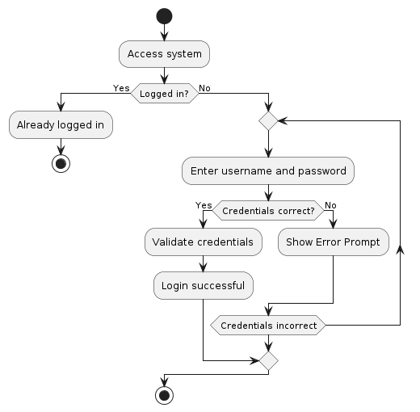

**Figure 3 Log-In Activity Diagram**

**Login:** The activity starts with the user accessing the login page. The system prompts for username and password. The user enters the credentials, and the system validates them. If the credentials are correct, the user is logged in, and the system displays the dashboard. Otherwise, an error message is shown, prompting the user to retry.

#### Usecase 003:

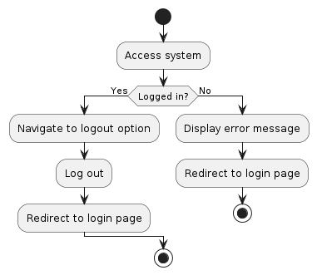

**Figure 4 Log-Out Activity Diagram**

**Logout:** The activity begins with the user accessing the logout option in the system. Upon selection, the system confirms the user's intention to logout. Once confirmed, the system terminates the user's session, logging them out and redirecting them to the login page.

#### Usecase 004:

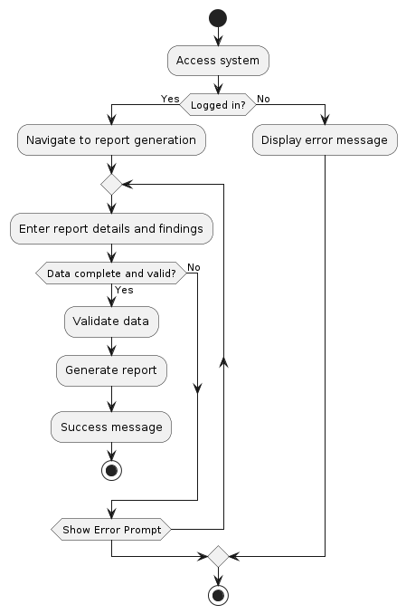

**Figure 5 Generate Reports Activity Diagram**

**Generate Reports:** The activity starts with the analyst navigating to the report generation section. The system prompts the analyst to enter report details and findings. After data entry, the system validates the information. If valid, the system generates the report and displays a success message. Otherwise, the analyst is prompted to correct any errors.

#### Usecase 005:

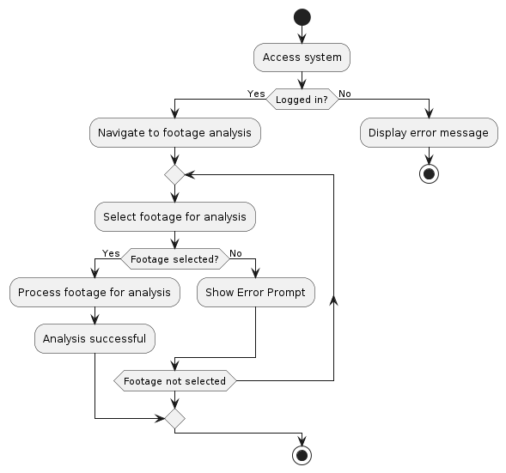

**Figure 6 Analyze Footage Activity Diagram**

**Analyze Footage:** The activity begins with the analyst selecting the option to analyze footage. The system prompts the analyst to upload the surveillance footage for analysis. Once uploaded, the system processes the footage using AI algorithms. The analyst then reviews the analysis results provided by the system.

#### Usecase 006:

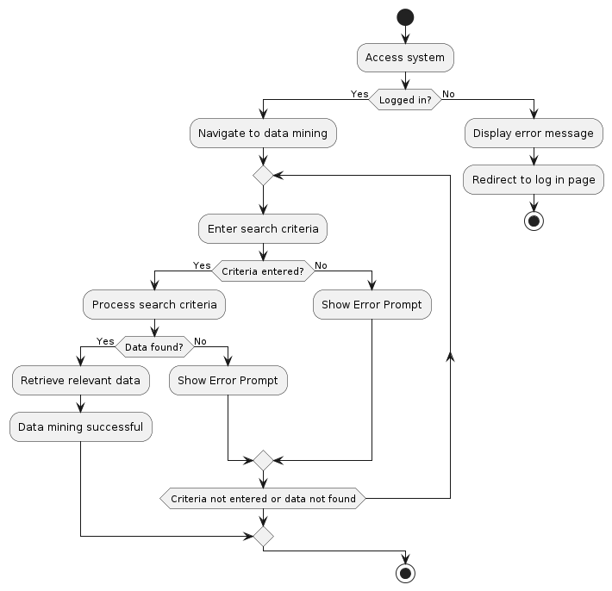

**Figure 7 Conduct Data Mining Activity Diagram**

**Conduct Data Mining:** The activity starts with the analyst accessing the data mining section. The system prompts the analyst to specify search criteria. The analyst enters the criteria, and the system performs data mining operations on the integrated surveillance and satellite data. The system then presents the mined data to the analyst for further analysis.

#### Usecase 007:

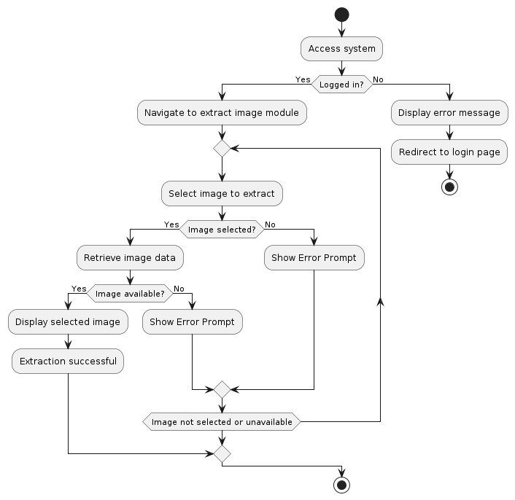

**Figure 8 Extract Image from Satellite Image Module Activity Diagram**

**Extract Image from Satellite Image Module:** The activity begins with the analyst accessing the satellite image processing module. The system provides options to extract images from the module. The analyst selects the desired image and requests extraction. The system retrieves the image and presents it to the analyst for analysis.

#### Usecase 008:

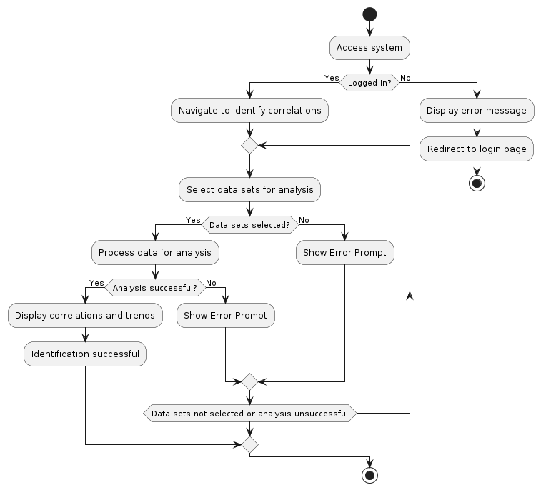

**Figure 9 Identify Correlations and Trends to Feed the AI Activity Diagram**

**Identify Correlations and Trends to Feed the AI:** The activity starts with the analyst accessing the data analysis section. The system prompts the analyst to identify correlations and trends in the data. The analyst performs analysis tasks and identifies relevant patterns. The system then processes this information to feed the AI for further learning and analysis.

#### Usecase 009:

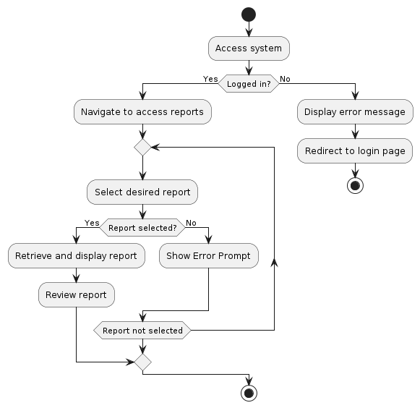

**Figure 10 Access and Review Reports Activity Diagram**

**Access and Review Reports:** The activity begins with the operator accessing the system and navigating to the reports section. The system presents a list of available reports. The operator selects a report to review. The system displays the report content, including surveillance findings and causality insights. The operator reviews the report and can take further actions based on the information provided.

#### Usecase 010:

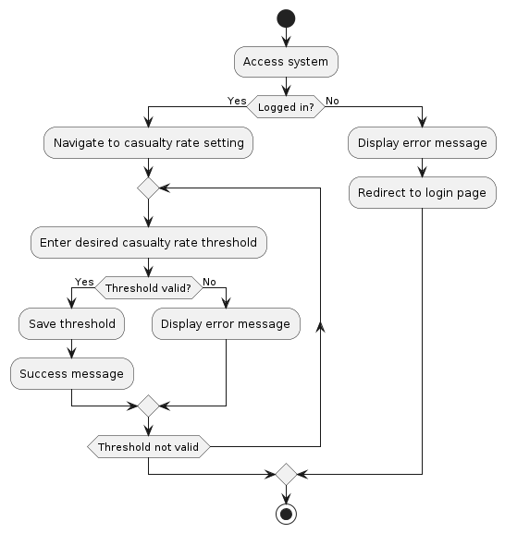

**Figure 11 Set Casualty Rate Activity Diagram**

**Set Casualty Rate:** The activity starts with the operator accessing the system and navigating to the incident management section. The system prompts the operator to select a specific incident. The operator then sets the casualty rate for the selected incident based on available information and assessment. Once set, the system confirms the action and updates the incident details accordingly.

#### Usecase 011:

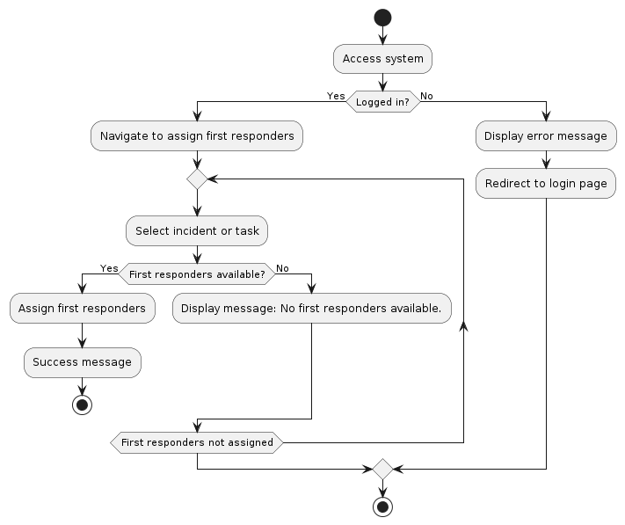

**Figure 12 Assign First Responders Activity Diagram**

**Assign First Responders:** The activity begins with the operator accessing the incident management section of the system. The system presents a list of active incidents requiring first responders. The operator selects an incident and assigns first responders based on availability and expertise. The system updates the incident status and notifies the assigned first responders.

#### Usecase 012:

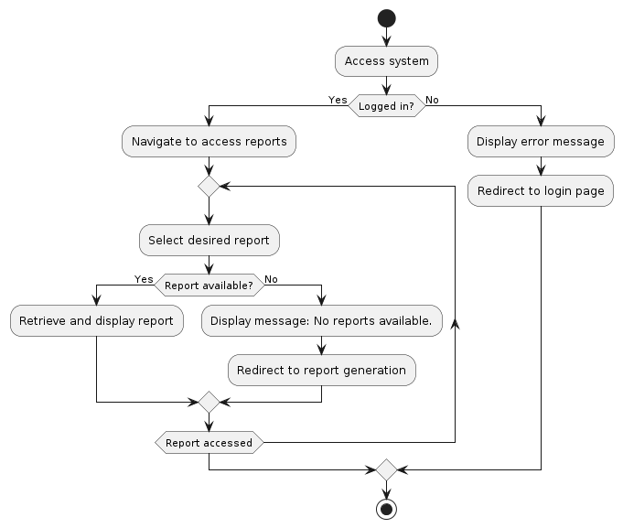

**Figure 13 Access Report Activity Diagram**

**Access Report:** The activity starts with the first responder accessing the system and navigating to the reports section. The system presents a list of available reports related to incidents. The first responder selects a report to access. The system displays the report content, including incident details and actions taken. The first responder reviews the report for reference or further action.

#### Usecase 013:

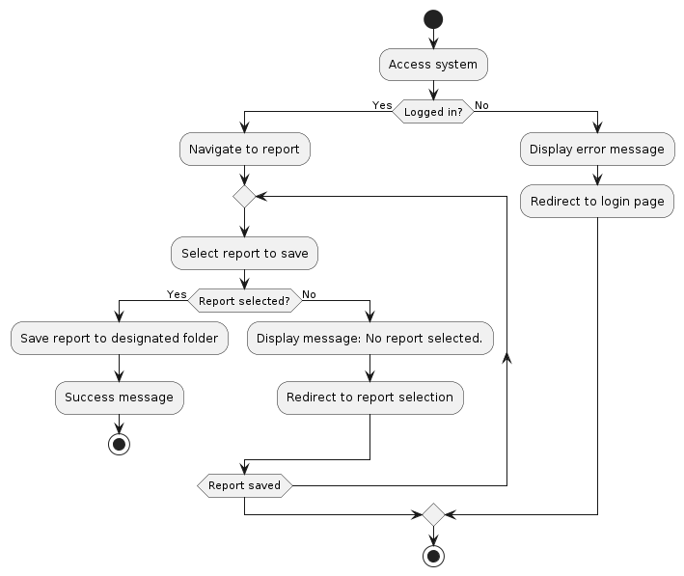

**Figure 14 Save Report Activity Diagram**

**Save Report:** The activity begins with the first responder accessing a report within the system. The system provides an option to save the report for future reference. The first responder selects the save option, and the system saves the report to the user's profile or designated storage location. A confirmation message is displayed upon successful saving of the report.

#### Usecase 014:

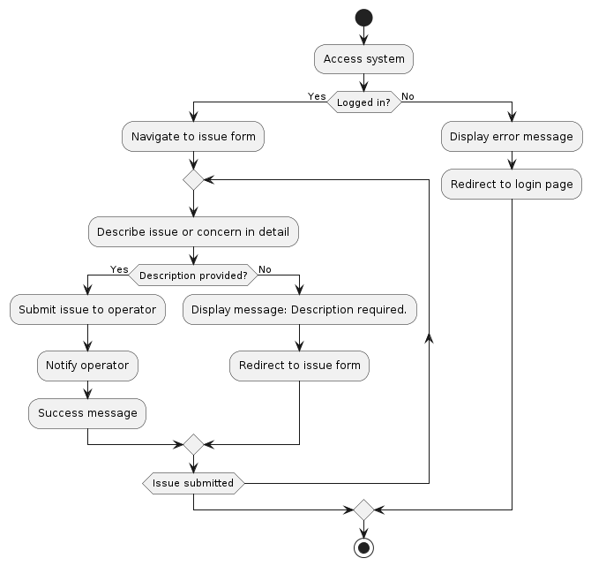

**Figure 15 Raise Issue to Operator**

**Raise Issue to Operator:** The activity starts with the first responder encountering an issue during incident response. The first responder accesses the system and selects the option to raise an issue. The system prompts the first responder to describe the issue in detail. Once submitted, the system notifies the operator about the raised issue for further action.

#### Usecase 015:

**Figure 16 Upload Ground Footage Activity Diagram**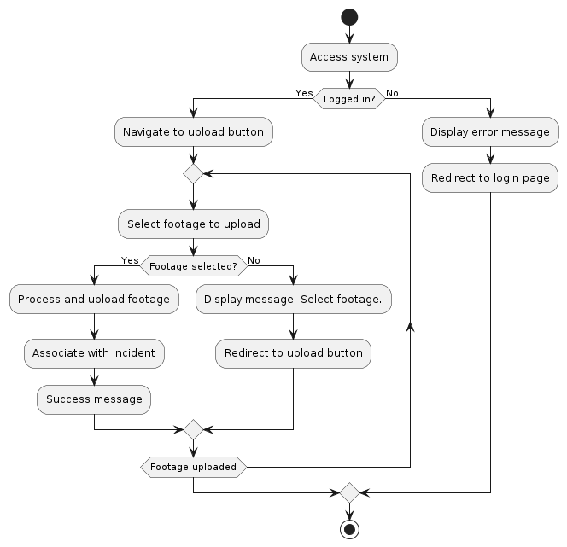

**Upload Ground Footage:** The activity begins with the first responder accessing the system and selecting the option to upload ground footage. The system prompts the first responder to select the incident to which the footage belongs. The first responder uploads the footage file, and the system processes and associates it with the selected incident for further analysis.

#### Usecase 016:

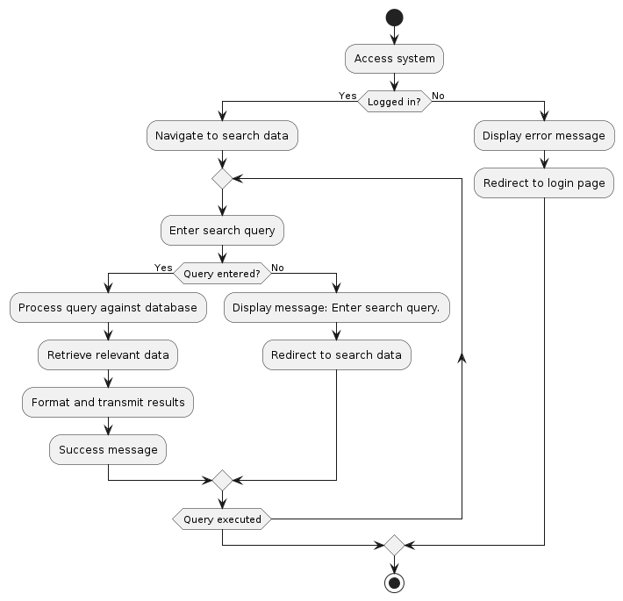

**Figure 17 Send Searched Data Activity Diagram**

**Send Searched Data:** The activity starts with the data mining engine performing a search operation based on specified criteria. Once the search is completed, the engine sends the searched data to the analyst for review and analysis. The system notifies the analyst about the availability of new data for further exploration and insights generation.

#### Usecase 017:

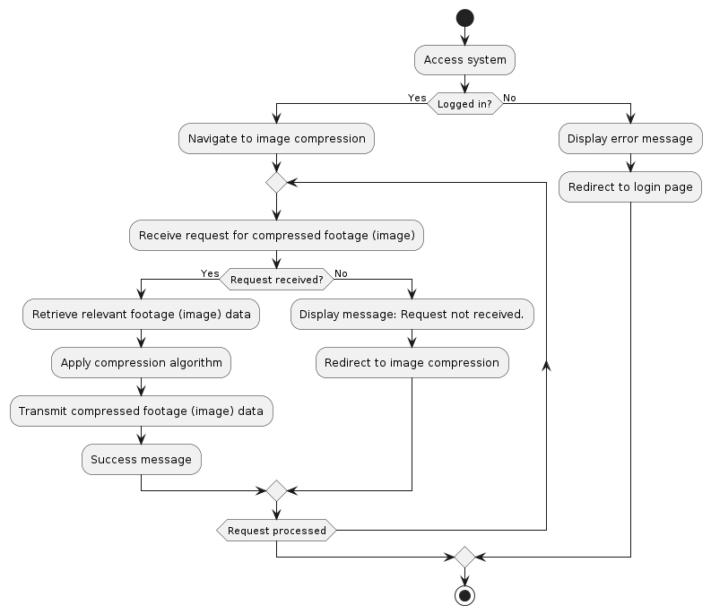

**Figure 18 Send Compressed Footage (Image) Activity Diagram**

**Send Compressed Footage (Image):** The activity begins with the satellite image processing module compressing surveillance footage or images. Once compressed, the module sends the footage or image to the analyst for analysis or inclusion in reports. The system confirms successful transmission of the compressed data to the analyst for further processing.

#### Usecase 019:

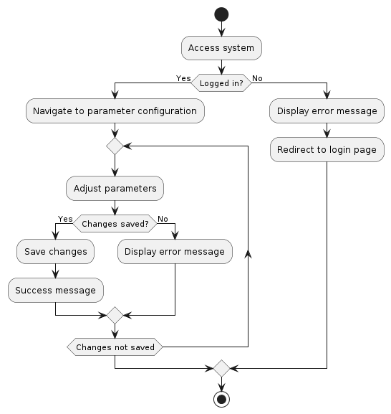

**Figure 19 Configure Parameters Activity Diagram**

**Configure Parameters:** The activity starts with the user accessing the system's configuration settings. The system presents options to configure various parameters related to surveillance, data analysis, and reporting. The user selects the parameters to configure and enters the desired values. Once configured, the system applies the changes and updates the system settings accordingly.

### 2.4.4 Sequence Diagram

### 

**Figure 20 Sequence Diagram**

### The system's sequence diagram provides a detailed representation of the interactions and messages exchanged between various objects and components within the system. It illustrates the sequence of actions and the flow of control between different entities during the execution of use cases. The diagram begins with the initiation of use cases by actors such as administrators, analysts, operators, and first responders. Each use case involves a series of interactions between the actors and system components, including requests, responses, and data exchanges. These interactions encompass tasks such as user registration, authentication, report generation, data analysis, incident management, and system integration. The sequence diagram captures the chronological order of events and the dependencies between different actions, highlighting how each step contributes to the overall functionality of the system. Additionally, it demonstrates how system components collaborate to fulfill user requirements and achieve the system's objectives in a cohesive and efficient manner.

### 2.4.5 CRC (Class Responsibility and Collaboration) Card

|  |
| --- |
| **Class: Analyst** |

|  |  |
| --- | --- |
| **Responsibilities** | **Collaborators** |
| Generate report | Operator |
| Analyze footage | Report |
| Conduct data mining | Footage |
| Extract image |  |
| Identify correlations and trends |  |
| UserID |  |
| Username |  |
| Password |  |
| Role |  |
| SecurityLevel |  |
|  |  |

**Table 19 Analyst CRC**

| **Class: Operator** |
| --- |

|  |  |
| --- | --- |
| **Responsibilities** | **Collaborators** |
| Access report | Analyst |
| Set casualty rate | First Responder |
| Assign first responder | Report |
| UserID |  |
| Username |  |
| Password |  |
| Role |  |
| SecurityLevel |  |

**Table 20 Operator CRC**

**Class: Operator**

Responsibilities:

* Access Report: Operation to access and view reports.
* Set Casualty Rate: Operation to set the casualty rate for an incident.
* Assign First Responder: Operation to assign a first responder to an incident.

Collaborators:

* Incident: Collaborates with the operator class in a many-to-one relationship for managing incidents.

|  |
| --- |
| Class: FirstResponder |

|  |  |
| --- | --- |
| **Responsibilities** | **Collaborators** |
| Access report | Operator |
| Save report | Report |
| Raise issue to operator | Footage |
| Upload footage | Issue |
| UserID |  |
| Username |  |
| Password |  |
| Role |  |
| SecurityLevel |  |

**Table 21 First Responder CRC**

Responsibilities:

* Save Report: Operation to save a report related to an incident.
* Raise Issue to Operator: Operation to raise issues related to an incident to the operator.
* Upload Footage: Operation to upload footage related to an incident.

Collaborators:

* Incident: Collaborates with the first responder class in a many-to-one relationship for managing incidents.

Data-Mining Engine

|  |  |
| --- | --- |
| **Responsibility** | **Description** |
| Perform data mining | This operation performs data mining to extract valuable insights from the data. |
| Send searched data | This operation sends the searched data to the appropriate components or users. |

|  |  |
| --- | --- |
| **Data Attributes** | **Description** |
|  | There are no specific data attributes associated with the **DataMiningEngine** class. |

|  |  |
| --- | --- |
| **Collaborators** | **Description** |
| User | Collaborates with the **DataMiningEngine** class to receive searched data. |
| Report | Collaborates with the **DataMiningEngine** class to provide data for analysis. |

**Table 22 Data-Mining Engine**

The Data-Mining Engine class serves as a critical component within the system, responsible for the extraction of valuable insights through data mining techniques. Its primary responsibilities include performing data mining operations and facilitating the dissemination of searched data to relevant users or components. By leveraging advanced algorithms and analytical methods, the Data-Mining Engine extracts patterns, correlations, and trends from the vast dataset available within the system.

This class collaborates closely with users and reports, receiving input data for analysis and providing valuable insights derived from the mining process. Through seamless integration with

**Class: SatelliteImageProcessingModule**

|  |  |
| --- | --- |
| **Responsibility** | **Description** |
| Process satellite images | This operation processes satellite images to extract relevant information. |
| Send compressed footage | This operation sends the compressed footage or images to the appropriate components or users. |

|  |  |
| --- | --- |
| **Data Attributes** | **Description** |
|  | There are no specific data attributes associated with the **SatelliteImageProcessingModule** class. |

|  |  |
| --- | --- |
| **Collaborators** | **Description** |
| User | Collaborates with the **SatelliteImageProcessingModule** class to receive compressed footage or images. |
| Incident | Collaborates with the **SatelliteImageProcessingModule** class to provide context for satellite images processing. |

**Table 23 Satellite Image Processing Module CRC**

The Satellite Image Processing Module class plays a pivotal role in the system's capabilities by processing satellite images to extract relevant information. Its core responsibilities include the processing of raw satellite imagery to derive actionable insights and the compression of footage or images for efficient storage and transmission.

Using advanced image processing techniques, the SatelliteImageProcessingModule enhances the system's ability to monitor and analyze events from a remote perspective, providing valuable visual data for incident management and analysis. It collaborates closely with users and incidents, receiving context and requirements for image processing and delivering compressed footage or images for further analysis or dissemination.

| **Class: Report** |
| --- |

|  |  |
| --- | --- |
| **Responsibilities** | **Collaborators** |
| Generate report | Analyst |
| Associate with incidents | Operator |
| ReportID | First Responder |
| AnalystID |  |
| GeneratedDate |  |
| Content |  |

**Table 24 Report CRC**

Responsibilities:

* Generate report: This operation is responsible for generating a report by the analyst.
* Associate with incidents: This operation associates the report with one or more incidents.

Data Attributes:

* ReportID: A unique identifier for each report.
* AnalystID: Identifies the analyst who generated the report.
* GeneratedDate: Date when the report was generated.
* Content: Content or details of the report.

Collaborators:

* Analyst: Collaborates with the report class to generate reports.

| **Class: Incident** |
| --- |

|  |  |
| --- | --- |
| **Responsibilities** | **Collaborators** |
| Manage incident | Operator |
| Associate with footage |  |
| IncidentID |  |
| Date |  |
| Location |  |
| Description |  |
| CasualtyRate |  |
| OperatorID |  |

**Table 25 Incident CRC**

Responsibilities:

* Manage incident: This operation manages the incident by the operator.
* Associate with footage: This operation associates the incident with one or more footage.

Data Attributes:

* IncidentID: A unique identifier for each incident.
* Date: Date when the incident occurred.
* Location: Location where the incident occurred.
* Description: Description of the incident.
* CasualtyRate: Casualty rate associated with the incident.
* OperatorID: Identifies the operator managing the incident.

Collaborators:

* Operator: Collaborates with the incident class to manage incidents.

| **Class: Footage** |
| --- |

|  |  |
| --- | --- |
| **Responsibilities** | **Collaborators** |
| Retrieve incident details | Incident |
| FootageID |  |
| IncidentID |  |
| FilePath |  |
| FileType |  |

**Table 26 Footage CRC**

Responsibilities:

* Retrieve incident details: This operation retrieves details of the incident associated with the footage.

Data Attributes:

* FootageID: A unique identifier for each footage.
* IncidentID: Identifies the incident associated with the footage.
* FilePath: Path to the file location of the footage.
* FileType: Type or format of the footage file.

Collaborators:

* Incident: Collaborates with the footage class to retrieve incident details.

**Class: Issue**

|  |  |
| --- | --- |
| **Class Name** | **Issue** |
| Responsibilities | RaiseIssue() |
| Collaborators | First Responder: Creates and updates issues.  Operator: Reviews and resolves issues. |

Table 27 Issue CRC

Responsibilities:

* Store information about an issue raised by a first responder.
* Provide methods to update the status and details of the issue.
* Allow retrieval of issue details.

Collaborators:

* First Responder: Creates and updates issues.
* Operator: Reviews and resolves issues.

### 2.4.6 Class Diagram

### 

**Figure 21 System Class Diagram**

#### Class Diagram Explanation:

1. **User Class:**
   * **Attributes:** UserID, Username, Password, Role, SecurityLevel.
   * **Methods:** Register, Login, Logout, ConfigureParameters, SetSecurityClearance.
2. **Analyst Class:**
   * **Inherits from User Class**
   * **Methods:** GenerateReport, AnalyzeFootage, ConductDataMining, ExtractImage, IdentifyCorrelationsAndTrends.
3. **Operator Class:**
   * **Inherits from User Class**
   * **Methods:** AccessReport, SetCasualtyRate, AssignFirstResponder.
4. **FirstResponder Class:**
   * **Inherits from User Class**
   * **Methods:** AccessReport, SaveReport, RaiseIssueToOperator, UploadFootage.
5. **DataMiningEngine Class:**
   * **Methods:** SendSearchedData.
6. **SatelliteImageProcessingModule Class:**
   * **Methods:** SendCompressedFootage.
7. **Issue Class:**
   * **Attributes:** IssueID, Description, Status, ReporterID, DateReported.
   * **Methods:** UpdateStatus, UpdateDetails, RetrieveDetails.

### Relationships:

* **User and Report:** One-to-Many (One user can create multiple reports)
* **User and Incident:** One-to-Many (One user can be associated with multiple incidents)
* **Report and Analyst:** Many-to-One (Many reports can be generated by one analyst)
* **Report and Incident:** One-to-Many (One report can be associated with multiple incidents)
* **Incident and Operator:** Many-to-One (Many incidents can be managed by one operator)
* **Incident and Footage:** One-to-Many (One incident can have multiple footages)
* **FirstResponder and Issue:** One-to-Many (One first responder can raise multiple issues)
* **Operator and Issue:** One-to-Many (One operator can resolve multiple issues)

This schema outlines the classes and their relationships within the "Integrated AI Surveillance & Satellite Data Analysis for Causality Reporting" system. The addition of the "Issue" class enhances the system's ability to manage and address reported issues effectively.